Ideation Phase
Define the Problem Statements

Date | 15 February 2026
Team ID | LTVIP2026TMIDS24256
Project Name | Heritage Treasures: An In-Depth Analysis of UNESCO World Heritage Sites in Tableau
Maximum Marks | 2 Marks

Customer Problem Statement Template:
Create a problem statement to understand your customer's point of view. The Customer Problem Statement template helps you focus on what matters to create experiences people will love.
A well-articulated customer problem statement allows you and your team to find the ideal solution for the challenges your customers face. Throughout the process, you’ll also be able to empathize with your customers, which helps you better understand how they perceive your product or service.

Reference: https://miro.com/templates/customer-problem-statement/
Example:
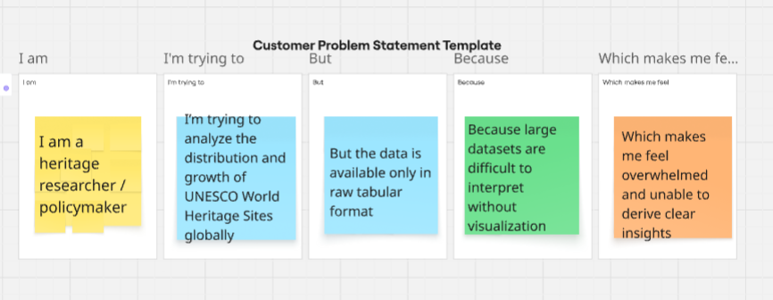
Problem Statement (PS) | I am (Customer) | I’m trying to | But | Because | Which makes me feel
PS-1 | I am a heritage researcher / policymaker | I’m trying to analyze the distribution and growth of UNESCO World Heritage Sites globally | But the data is available only in raw tabular format | Because large datasets are difficult to interpret without visualization | Which makes me feel overwhelmed and unable to derive clear insights
PS-2 | I am a conservation authority / cultural analyst | I’m trying to identify endangered heritage sites and prioritize preservation efforts | But there is no clear visual representation of sites at risk | Because the danger status is not summarized in an interactive way | Which makes me feel uncertain about where to focus conservation resources
These problem statements helped our team understand the perspective of stakeholders such as researchers, policymakers, and conservation authorities. By identifying their challenges, we focused on building an interactive Tableau dashboard that transforms complex heritage data into meaningful visual insights, helping users make informed decisions.

